Section 01 Document Information | Site: | Procedure Type: | System: | Equipment System:
 | STACK AMER | AP | Communication | Event Management
Review By Date:
10/25/2026
 | AP Overview:
 | Set standards and expectations for proper and efficient intra-event management and reporting. Also includes after-event analysis to identify real root causes.

Table of Contents
1) Version History 1
2) Purpose 1
3) Detailed Process and Policy 1
a) Scope 1
b) Event Report 2
c) Event Narrative and Response Actions 3
d) Generator Information 4
e) Root Cause Analysis 4
f) Corrective Action Plan 5
g) Event Report Library 5
h) Event Report Approvals 5
i) Event Report Review 5
2) References 5
3) Definitions 5

- Version History
Version | Date | Summary of Changes | Sections | Author(s)
10.1 | 6/15/2023 | -Updated title to Event Reporting  -Deleted Event Response Report  -Updated entire sections: 2.b), 2.c), and 2.f)  -Created sections 2.g), 2.h), 2.i) | 2) | Brad Hitchcock

Purpose
  - Set standards and expectations for proper and efficient intra-event management and reporting. Also, for complete after-event analysis to identify all root causes, corrective actions and lessons learned to ensure minimal repeat events and minimize future event impact.
- Detailed Process and Policy
  - Scope
    - This standard provides all guidance related to documenting and reporting during and after events. This includes an Event Response Report intended to be used during the event to track status and next steps. Also included is the Incident Report that is created with information from the Event Response Report along with in-depth engineering analyses to identify all true root-causes and corrective actions that apply to all data centers, not just the data center that experienced the failure.
  - Event Report
    - The Event Report will be used for all Severity 0-2 events. Severity 3 and 4 events do not require an Event Report, but site management and leadership can require as desired.
    - This report will be used to identify all engineering, process, people, program failures etc. that caused the event.
    - The site team will complete Event Information, Event Narrative and Response Actions, and Generator Information sections within 24 hours of site stabilization.
    - The site team will have a rough draft of the Event Report as identified in this document within 3 days of event stabilization.
    - The site team will have a complete Event Report as identified in this document within 7 days of event stabilization.
    - The regional operations leadership will assist, and support development as needed.
    - The regional operations leadership is responsible for the quality of the Event Report.
    - Gather all information required from the event and input the information into the Event Report Template:
      - This template can be found when the new button is clicked in the Event Report Library.
    - Event Title
      - To title the Event Report use the following format:
        - Event Title
          - A clear and concise title that tells the reader what the overall event was.
        - Numbering sequence: **SITE-YYYY-MM-DD-#
          - The # goes in sequential order and should be the total number of events that have happened at the site.
    - Event Information
      - Event Date/Time: Enter Event Start/Stabilization Date and Times in the applicable fields.
      - Event Report Author: List site operations person that owns creating the report.
      - STACK Executive Contact: List the regional STACK Executive Contact. (VP/Director)
      - Enter the weather condition descriptions that were prevalent during the event.
        - It is acceptable to add space or delete the stock parameters and enter “blizzard, tornado, hurricane” or other well-known titles for weather conditions as applicable.
        - If weather had no effect on the event, enter N/A.
      - Event Overview Description: Write a clear, concise, and accurate summary description of the event.
NOTE: The Event Overview field is meant to provide a clear, and effortless way to understand so that non-engineering personnel will have an overall understanding of the event and its impact on Client(s).
  - Event Narrative and Response Actions
    - Use this section to create an in-depth technical record of the event. Use any means available to provide clear details such as pictures, schematics, screenshots of monitoring/control systems.
    - In the first row, enter a description describing the facility's initial conditions, how they were identified and initial response actions such as acknowledging the alarm, and starting the applicable EOP.
    - Following the initial conditions and response add rows and enlarge rows as necessary to provide a full sequence of events, status changes, condition reports, stabilization milestones and notable communications.
      - Cross check this sequence with all involved personnel and data sources to include emails, alarms, phone logs, data graphs and tables, notes from communication bridge and any other available information.
    - This will be written in a third-person professional tone, past-tense and formal format. Ensure that acronym usage is minimal, grammar and spelling are checked, and have a peer review of the entire document prior to routing to leadership.
      - Do not include names of individuals, or company names.
        - For Example, use Critical Operations personnel instead of Critical Operation Technician or the name of the individual.
        - For third party vendors, do not use their company name. For example, for a switchgear company, call them the switchgear vendor.
    - Include visual aids and examples as beneficial directly into the table or as Appendices as applicable.
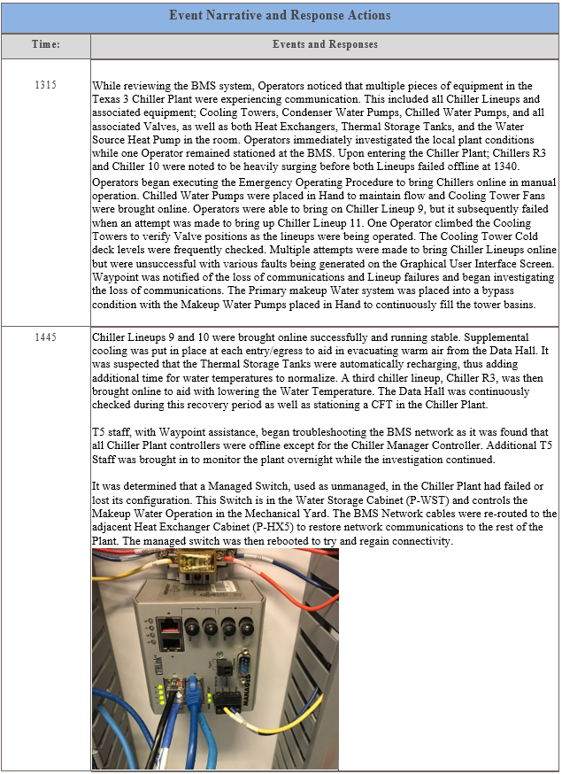
  - Generator Information
      - Generator run data will be entered based on actuals from event. Important data points are total run times and average load percentage for each generator. This data will be used along with generator O&M information to calculate generator emissions.
      - If the site has a generator logs and emissions calculator, the data will be transposed onto the Event Report with event totals.
    - If generators were running during the event, use best estimates and available data to complete run data.
  - Root Cause Analysis
    - Identifying Root Cause using the 5 Why Method.
      - Using a whiteboard or other similar format, the 5 Why Method will be used by personnel to identify all causes of the event.
      - Start by writing the agreed upon problem statement on the whiteboard.
      - Ask “Why did this happen?” about the problem statement.
      - Asking “Why" repeatedly is meant to identify the true root cause of failures. An acceptable level of “Why?” is 5 layers but it may take more or less to get to the true root cause(s).
      - At each level of “Why?”, question the logic previously applied in each iteration to ensure true root causes are being identified.
NOTE: Human error is very rarely a true root cause, the contributing factors that created the opportunity for human errors need to be identified during this exercise.
      - Example: The vehicle will not start.
- Why? – The battery is dead. (First why)
- Why? – The alternator is not functioning. (Second why)
- Why? – The alternator belt has broken. (Third why)
- Why? – The alternator belt was well beyond its useful service life and not replaced. (Fourth why)
- Why? – The vehicle was not maintained according to the recommended service schedule. (Fifth why, a root cause)
  - Corrective Action Plan
    - After the Root Cause Analysis, create specific corrective actions that will address each identified root cause.
    - Create NetSuite Corrective Maintenance Cases for each corrective action.
      - These cases shall be child cases of the event case.
      - Assign owners and set due dates,
  - Event Report Library
    - Each Event Report will be stored in the Event Report Library.
    - Technical Operations will maintain the library, and ensure each report goes through the proper routing for approval.
    - The System will be determined from the Event Case in NetSuite and should be the main system that caused the event to happen.
    - At no point shall these documents be checked out after they have been approved.
  - Event Report Approvals
    - All Severity 1 events shall have the Event Report approved by the Regional Vice President.
    - For Severity 2 events the event report can be approved by the Regional Director, however, the Regional Vice President has the right to make any report require their approval.
  - Event Report Review
    - Technical Operations is responsible for setting up and coordinating the report review with organization leadership.
    - Technical Operations is responsible for setting up and coordinating a report review with all site managers to present and review final Event Reports.
- References
  - STACK AMER-AP-Administrative-Event Management-Event Management Response

Definitions
  - STACK Executive: The STACK Regional Vice President or Director of Operations for the data center.
  - EPMS: Electrical Power Management System
  - BMS: Building Management System
  - Policy: Principles, guidelines or defined requirements formulated to reach a desired result.
  - Procedure: Step-by-step detailed directions on how to complete a specific task in the data center.
  - Equipment: Physical assets in the data center critical infrastructure such as emergency generator, air handling unit and a network switch.
  - People: Any person involved in the response as a site operator, offsite regional support, and leadership.
  - Maintenance: Preventative or Corrective tasks and standards.
  - Environment: The natural ambient conditions at the data center.

Section 02 | Document Approval
Peer Review: | Reviewers Name:  Brad Hitchcock | Date:  11/30/2022
Peer Review: | Reviewers Name:  Tony Badolato | Date:  06/21/2023
Management Approval: | Approvers Name:  Tom Harris | Date:  8/16/2023

